Reaction Time
The Game: When the beep plays, press the buzzer as quickly as possible. Your time in milliseconds will appear on the NXT screen. Who is the fastest person in the room? What is your time like when you use your other hand? Could you press the buzzer with your foot? Is that time faster or slower?

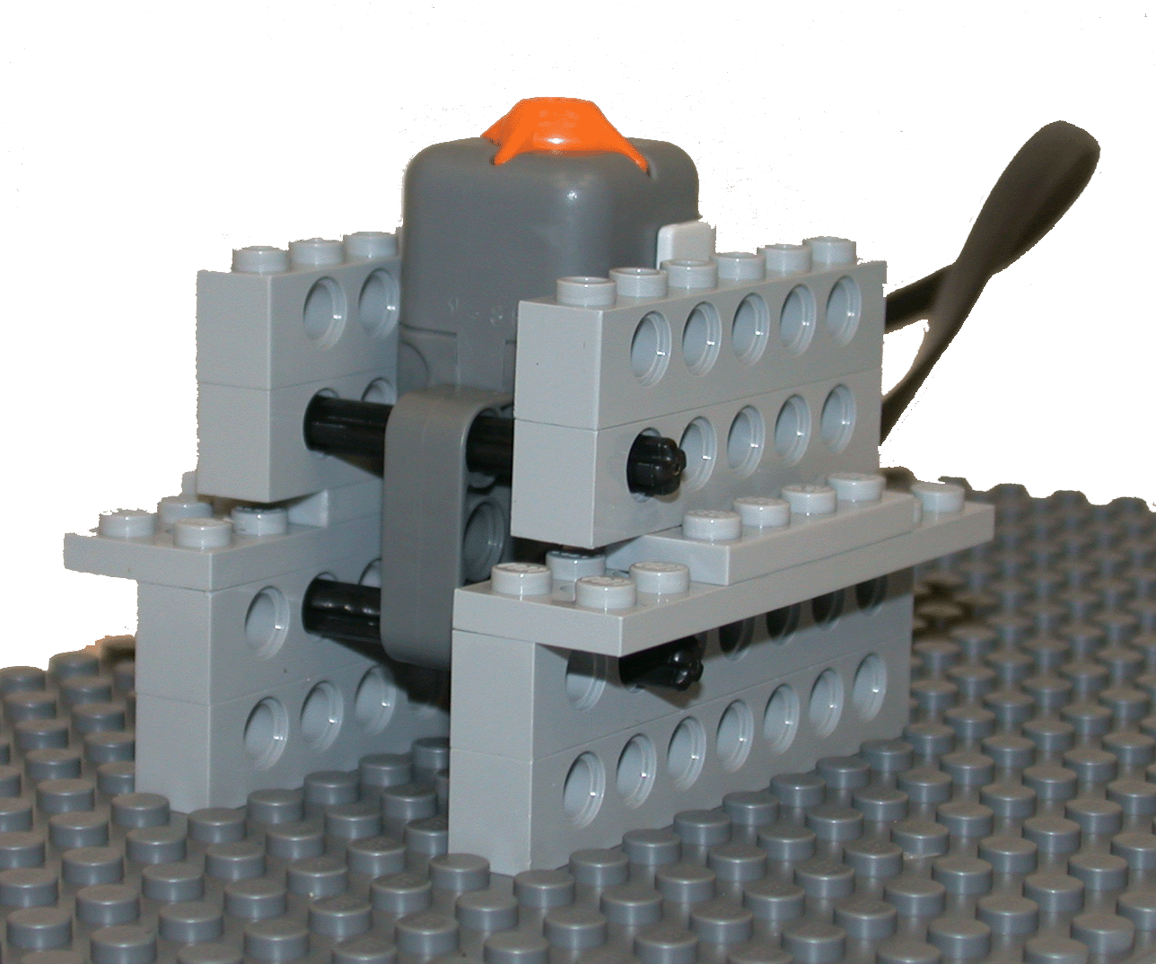
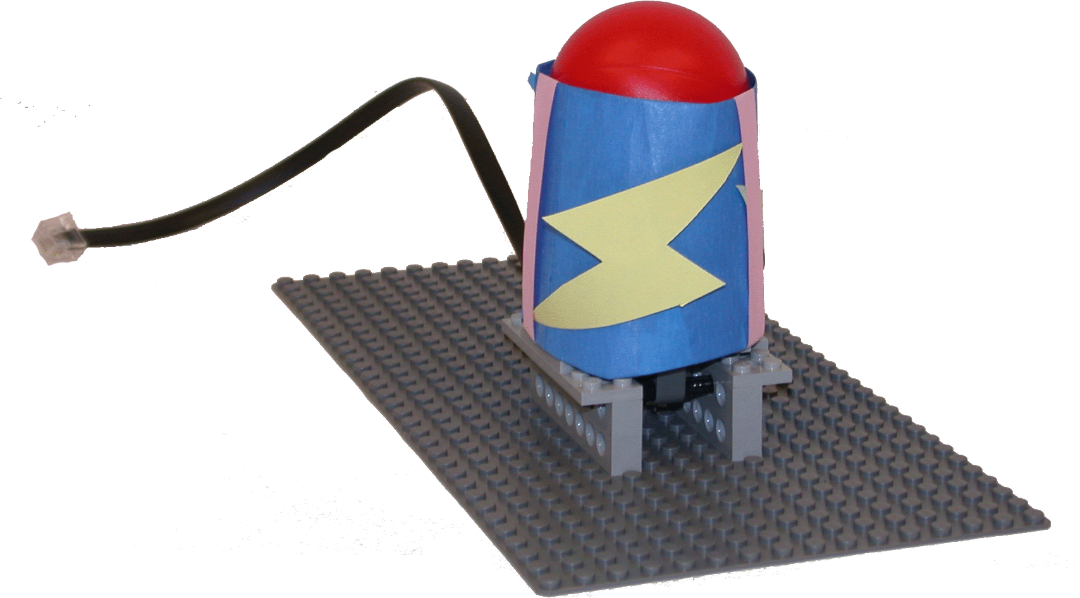
Using a touch sensor, LEGO bricks with holes, axels, a ball and paper,
create your own reaction-time game.
Start by making a cylinder out of paper large enough for your ball.
Make it a loose fit, as your ball will need to move up and down inside
the cylinder.
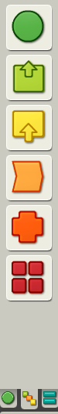
Next, connect the touch sensor to the base plate. Can your cylinder fit
around the top of the touch sensor? Is it secure or does it fall off?
With the cylinder over the sensor, is the ball too high or too low?
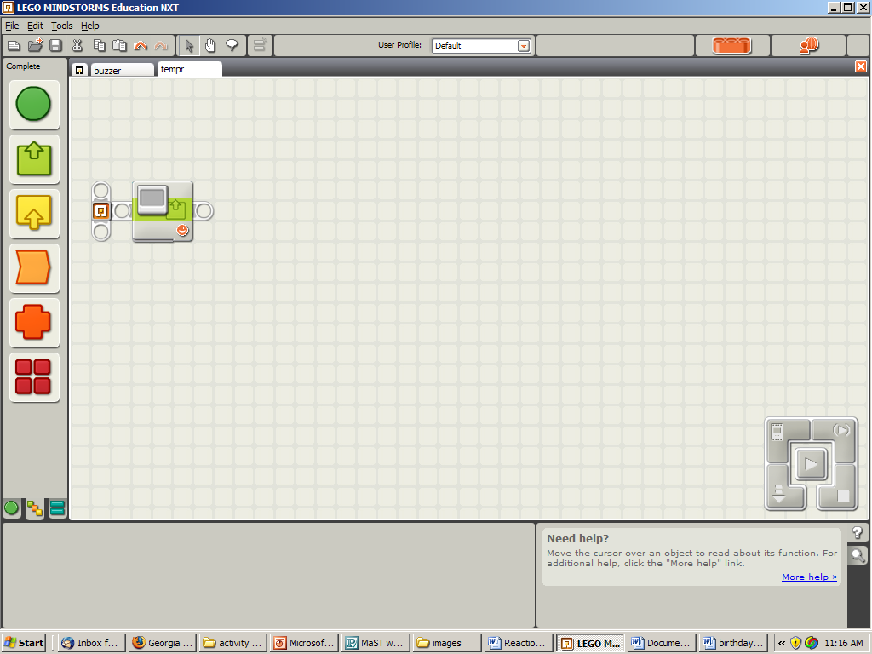
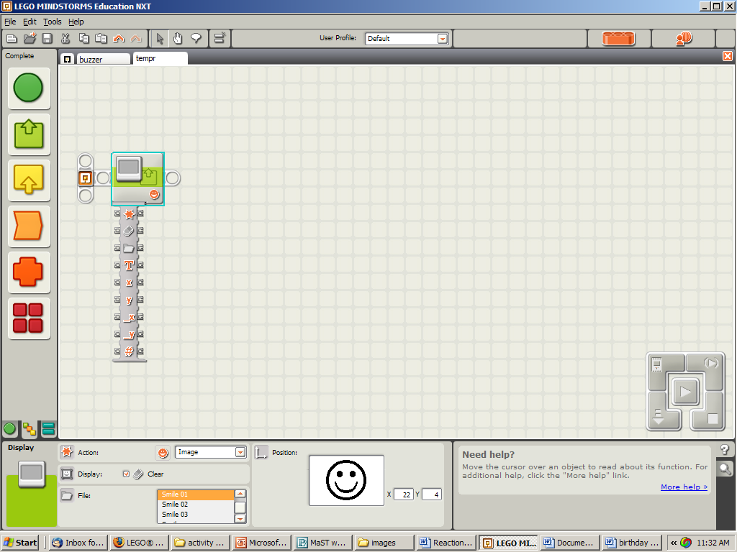
Modify your design until it works well for you, decorate your
game show buzzer, and then begin programming.

Use the “complete palette” to write your program
- To open the “data hub,” click the tab at the bottom of the block.
- Use your mouse to draw wires between the data plugs. Properly drawn wires are solid lines. Broken wires are black dashed lines.

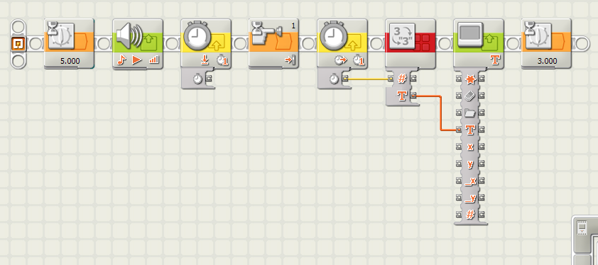

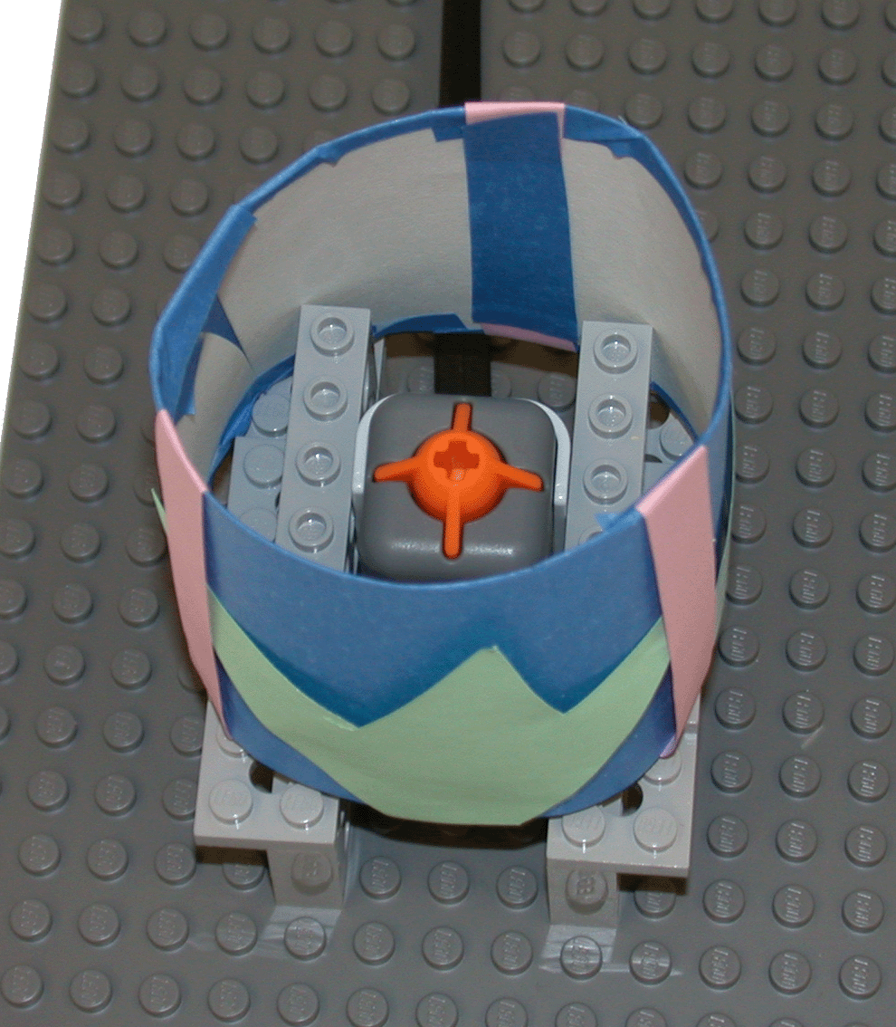

Block 1 – Wait for 5 seconds
Bock 2 – Sound (Play a tone for ZERO seconds)
Block 3 – Time (Reset)
Block 4 – Wait for Touch Sensor
Block 5 – Time (Read)
Block 6 – Number to Text
Block 7 – Display (choose text)
Block 8 – Wait for 3 seconds (this is how long the number will be displayed)

